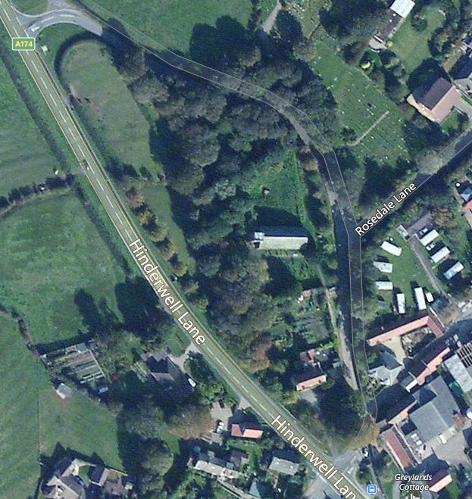
St. Hilda’s Holy Well
Location Map
TS13. 5JZ
OS Eastings: 479142
OS Northings: 516970
OS Grid: NZ791169

Transport & Access
Main A174 road provides access
to Hinderwell, with frequent buses
between Whitby and Loftus
(Arriva Buses)
On road parking only available
Main A171 road provides access to Scaling Dam
Arriva Bus Service (Whitby to Middlesbrough)
Parking & Toilets
Villages along the Esk Valley,
Whitby to Middlesbrough Train Service
varies according to the time of the year

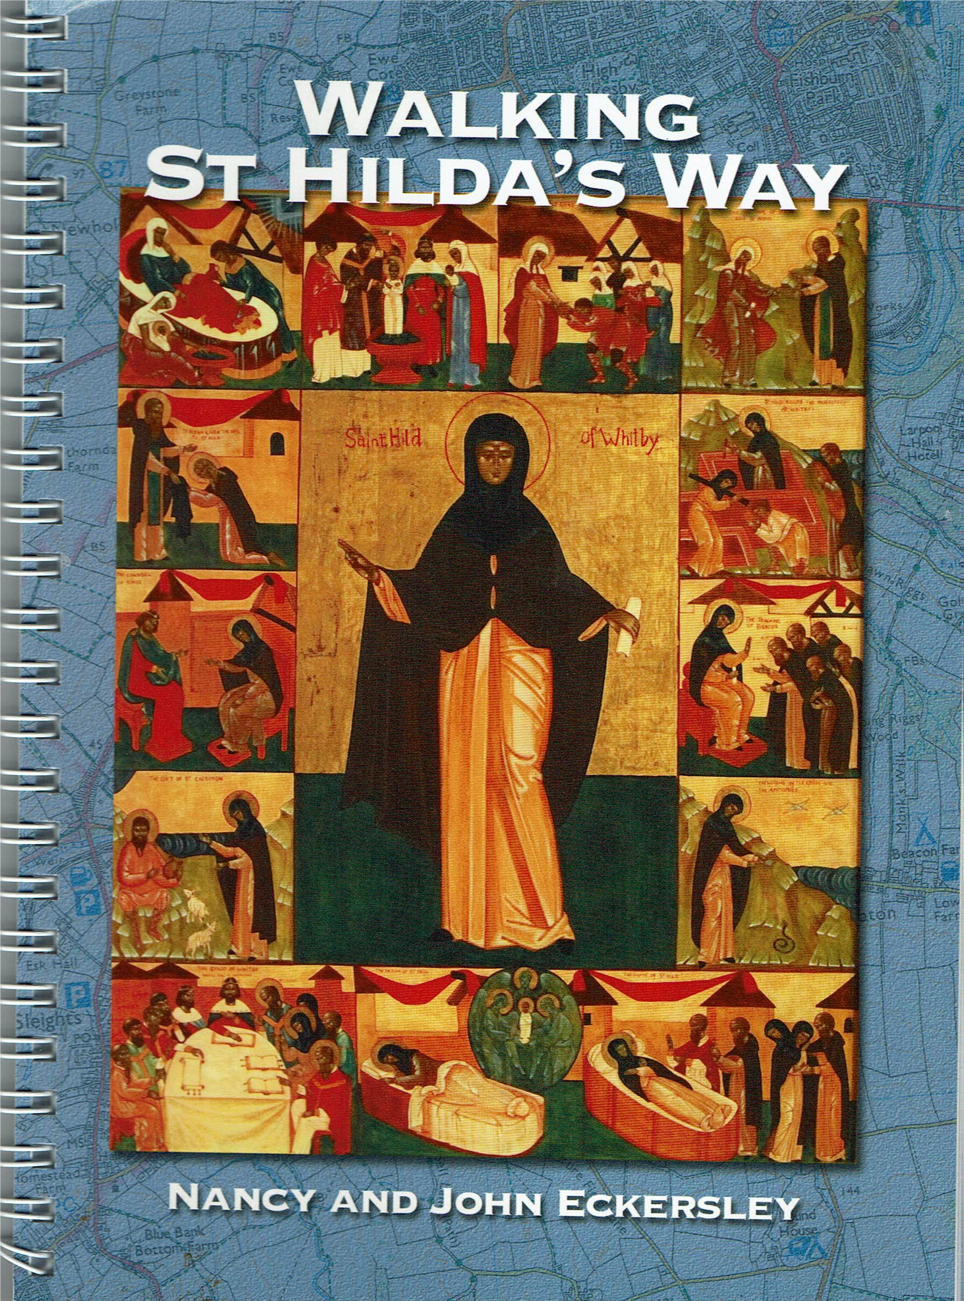
Distributors :
http://www.dalescourtpress.co.uk/
https://johneckersley.wordpress.com

St. Hilda’s Way was launched in 2015
to celebrate the birth of Hilda
1400 years earlier in 614.
The Walk passes through
the delightful scenery of the
North York Moors and River Esk Valley,
and visits eight Churches and Chapels
all dedicated to St Hilda, as well as
two other churches
named after St Hedda and St Mary

Walking – Moderate difficulty
includes ascent and descent
Route
Hinderwell-Scaling Dam-Danby-Lealholm-
Glaisdale-Egton Bridge-Egton-Sleights-
Ruswarp-Sneaton-Whitby

© MCRP

.

ST. HILDA’S WAY
A new 40mile walk
from
St. Hilda’s Holy Well
Hinderwell
to
Whitby Abbey



50p
50p

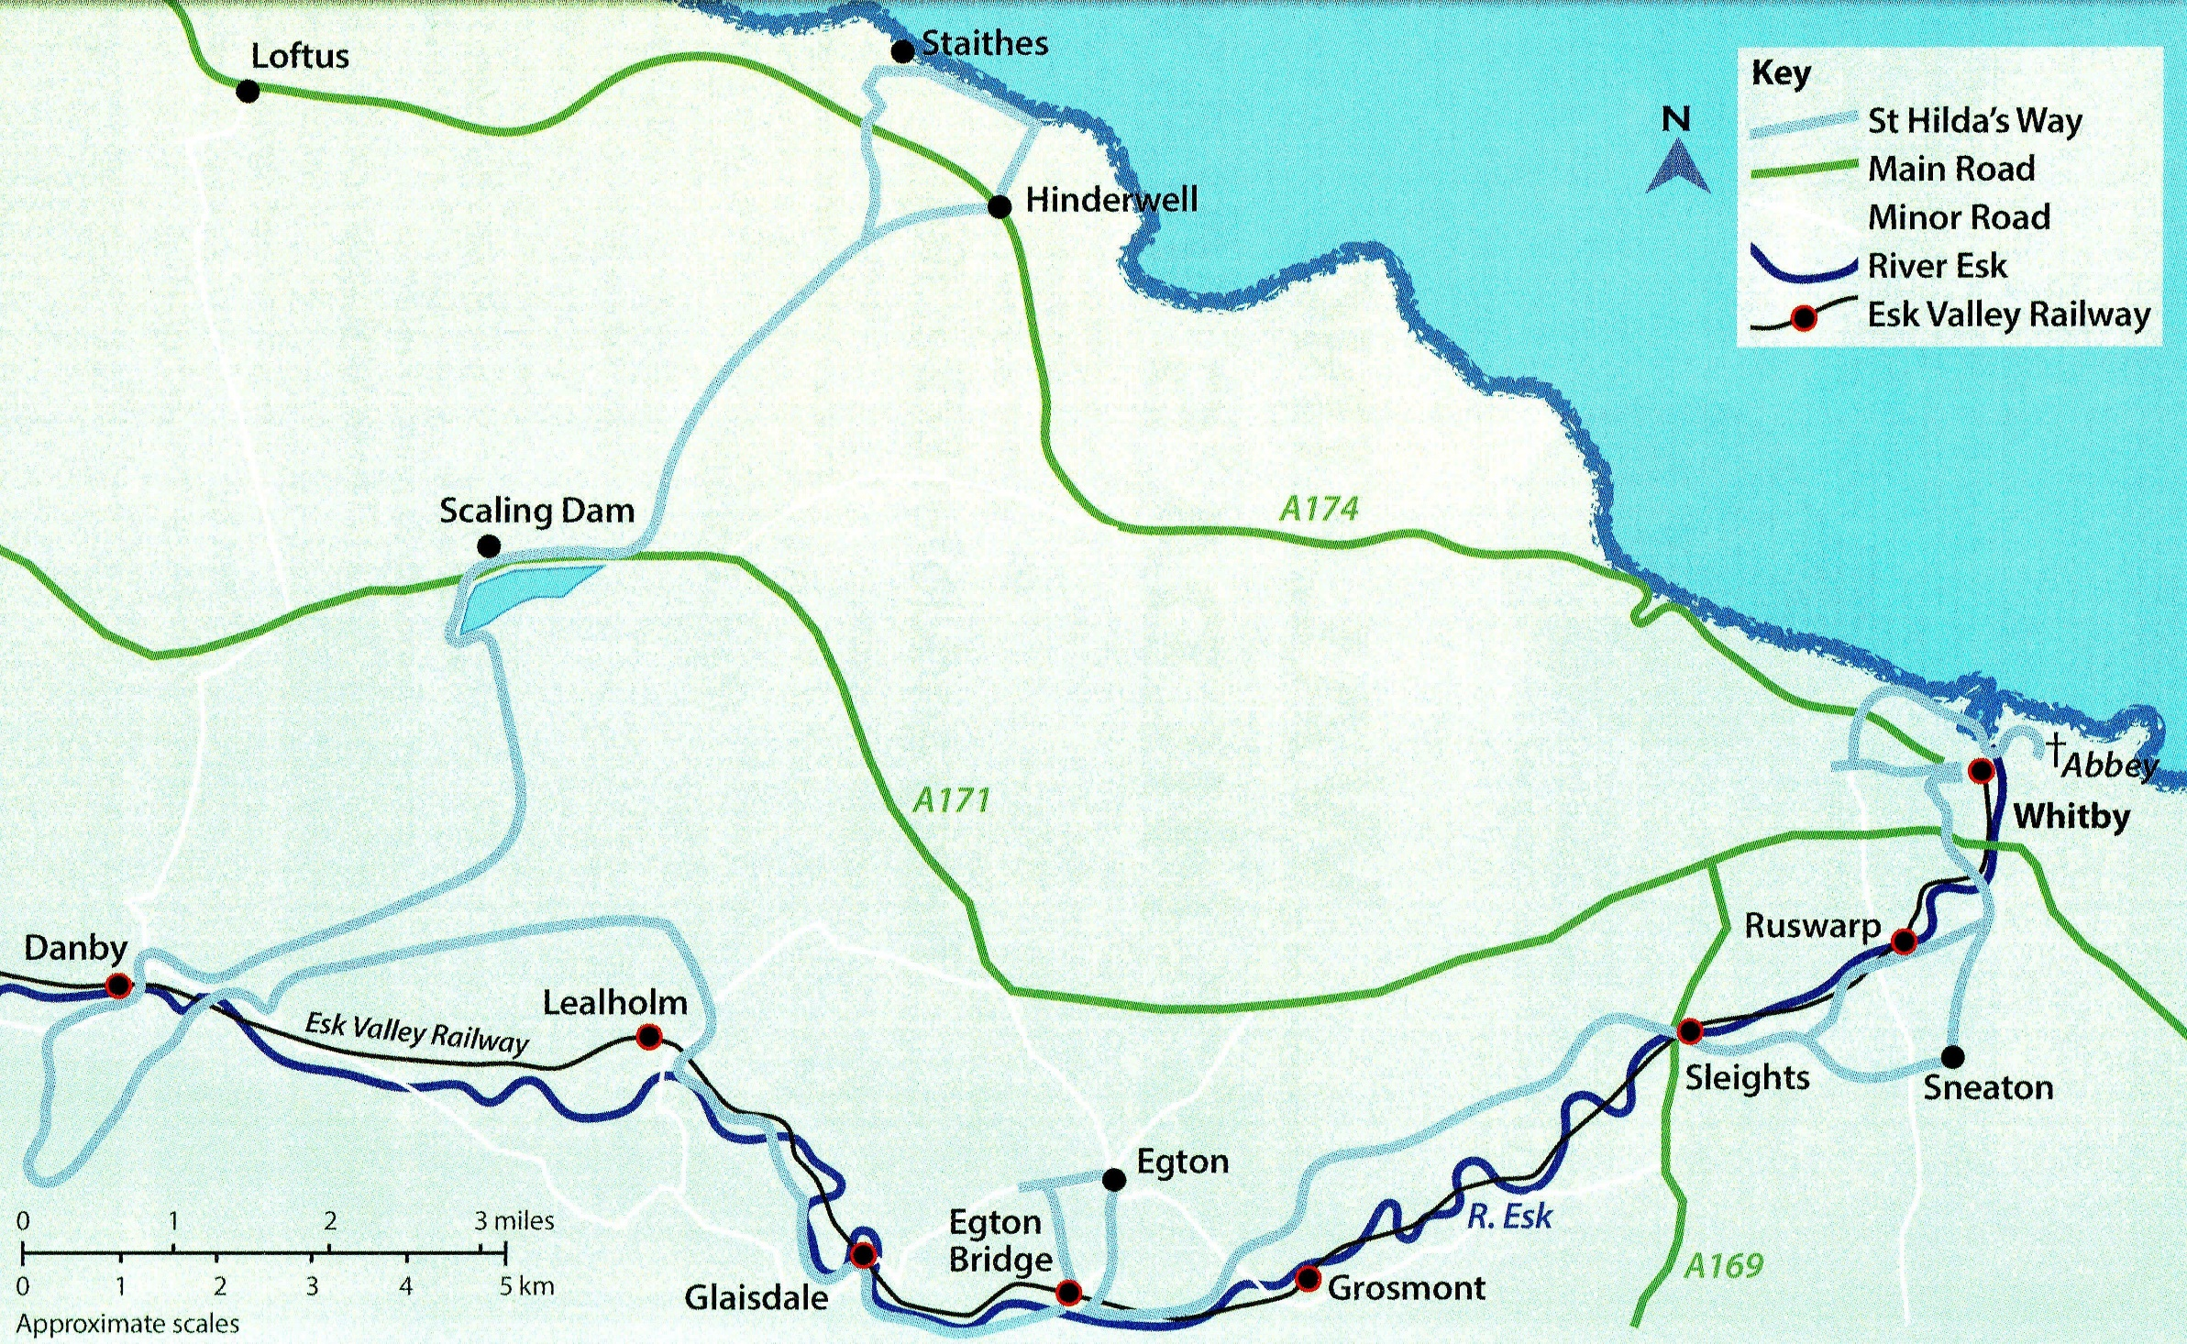
WALKING ST. HILDA’S WAY BOOKLET by Nancy & John Eckersley. ISBN978-0-9567890-2-0 Published by Jet Coast Development Trust – MULGRAVE COMMUNITY RESEARCH PROJECT

