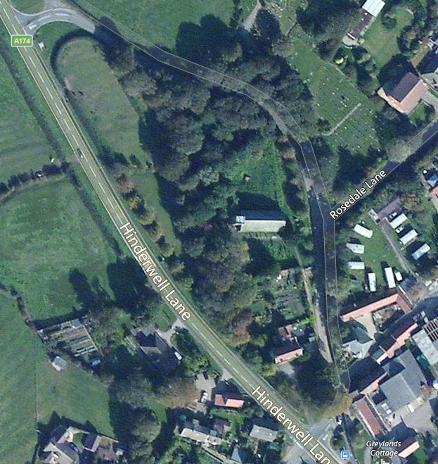
St. Hilda’s Church & Holy Well
Location Map
TS13. 5JX
OS Eastings: 479142
OS Northings: 516970
OS Grid: NZ791169

Transport & Access
Main A174 road provides access
to Hinderwell, with frequent buses
between Whitby and Loftus
(Arriva Buses)
On road parking only available

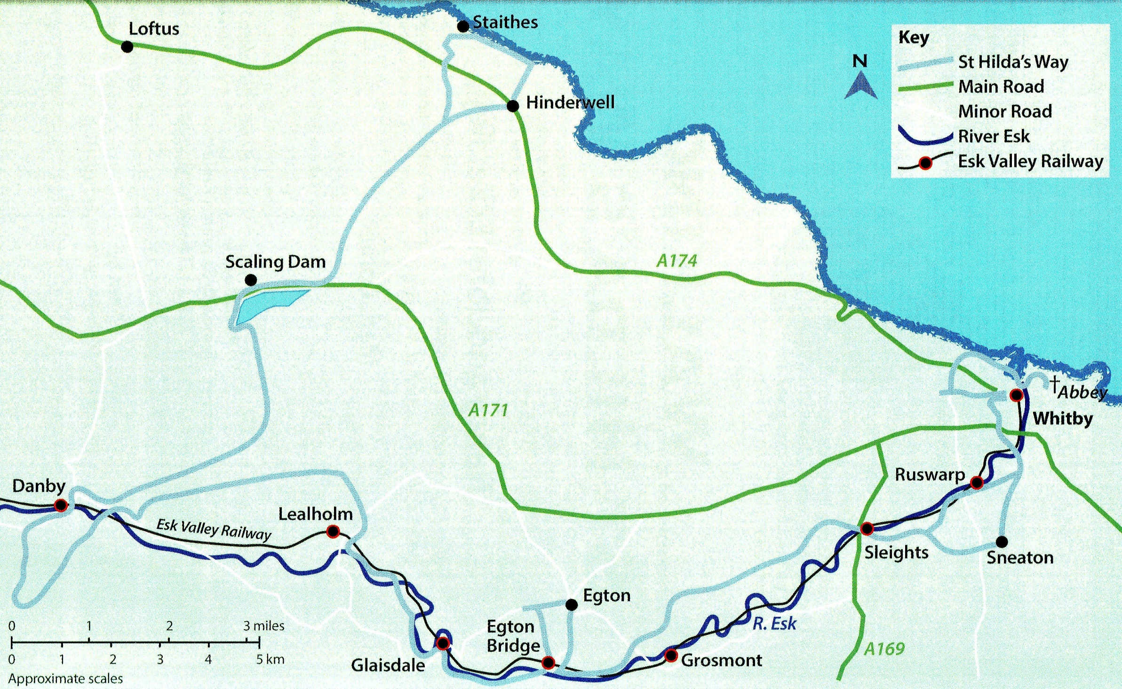

St. Hilda's Way Route

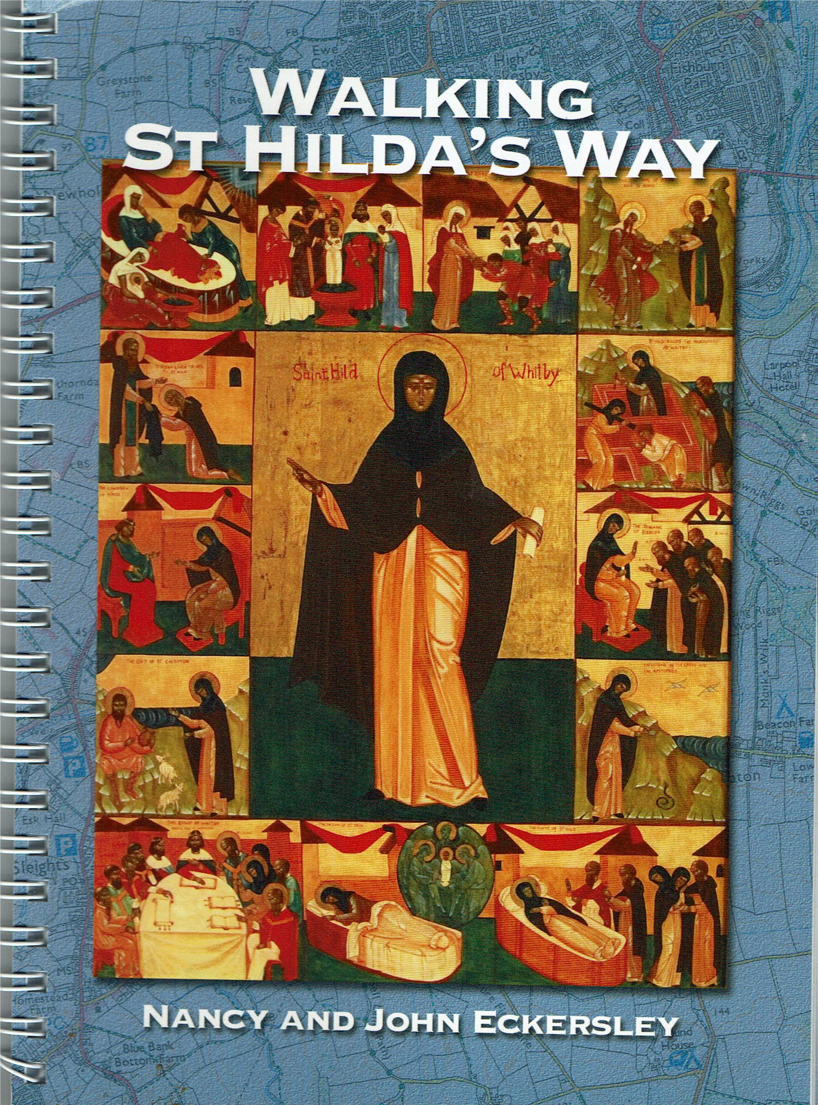
Distributors :
http://www.dalescourtpress.co.uk/
https://johneckersley.wordpress.com

St. Hilda’s Way was launched in 2015
to celebrate the birth of Hilda
1400 years earlier in 614.
The forty mile walk starts
at St. Hilda’s Well, and passes through
the delightful scenery of the
North York Moors and River Esk Valley,
Visit eight Churches and Chapels
all dedicated to St Hilda, as well as two other churches named after St Hedda and St Mary

Walking
Moderate difficulty
includes ascent and descent
Route
Hinderwell-Scaling Dam-Danby-Lealholm-
Glaisdale-Egton Bridge-Egton-Sleights-
Ruswarp-Sneaton-Whitby

Published by Jet Coast Development Trust
Mulgrave Community Research Project

.

ST. HILDA’S
CHURCH
&
HOLY WELL
Hinderwell



50p
50p

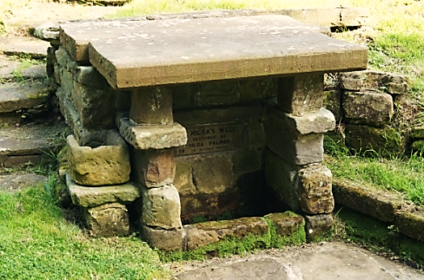
Hinderwell, is the centre of the parish, which was once an Urban Council area. It is mentioned in the Domesday Book as Hildrewell, a derivation of Hilda’s Well.
Hinderwell's church, is dedicated to St. Hilda, but the Holy Well in the churchyard has much earlier origins and probably gave its name to the village. According to legend, St. Hilda was asked to intercede in a drought whilst travelling through the parish. Her prayers were answered, and the spring which appeared, has continued to bubble from the hillside to this day.
The waters were said to have healing properties particularly for eye diseases, and the Well became a place of pilgrimage during the Middle Ages.
The Well is the only Scheduled Ancient Monument in the parish.
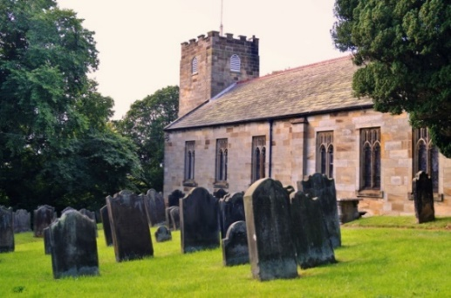
St Hilda is said to be responsible for the ammonites or fossilised mollusca shells often found along this coastal stretch, as they resemble curled-up headless snakes. According to legend, she had prayed for all the snakes of the neighbourhood to lose their heads and turn to stone. For this reason ammonites are known locally as St Hilda's Snakes. St. Hilda’s Day is on 17th November..

ST. HILDA’S PARISH CHURCH dates from 1773, but the tower was rebuilt in 1817, and replaces an older structure apparently of late 12th century date, or at any rate incorporating some work of that period.
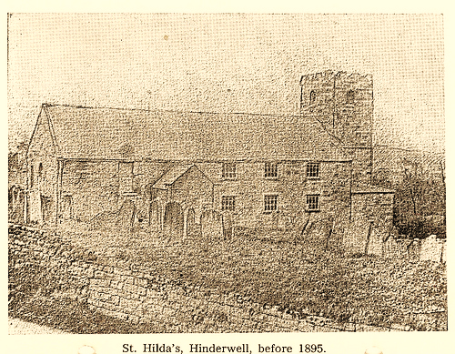
The church was restored in 1895. It is constructed of wrought stone with quoins at the angles and is lighted by six square-headed windows on each side, and at the east end is a window of three lights of 'Venetian' type now built up and treated internally as an altar-piece. This window, the middle light of which has a semicircular head, is quite plain outside, but internally has an entablature over the side lights carried on Tuscan pilasters, and a keyed architrave to the middle opening. The north and south windows, which were of the usual plain 18thcentury type, were gothicized in 1895 and now have perpendicular tracery in the heads.
The roof is eaved and has been re-slated and the east gable is quite plain. There is a gallery at the west end erected in 1818, now containing the organ. The font, pulpit, and all the internal fittings are modern. The tower, which contains the gallery staircase, has round-headed belfry windows and south doorway.
The plate includes a mediaeval chalice and paten of great interest. They are both apparently of late 15th-century date, c. 1490, and the chalice is of parcel-gilt. It has a deep bowl and hexagonal stem and foot. The gilt portions are the inside and rim of the bowl, the knop, and the front compartment of the foot. In this latter is engraved a crucifix with attendant figures of St. Mary and St. John. The chalice is 6¼ in. high. The paten is a thin plain saucer-shaped plate with a plain rim. In the centre is the Agnus Dei, with growing grass and flowers. There are slight traces of gilding on the paten, the diameter of which is 6¼ in. The plate also includes a cup of 1777, without inscription, and a pewter flagon.
Church Registers date back to 1601, written in Latin.

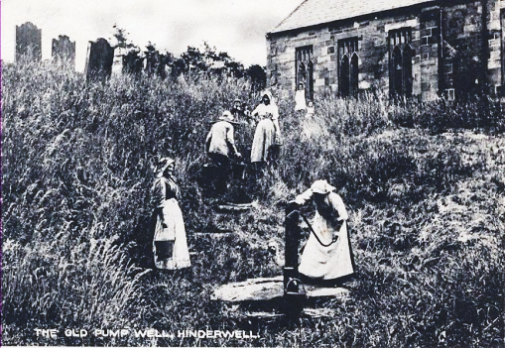
ST. HILDA’S WELL The spring water collects in a covered chamber behind the well and then flows into a small trough between the pillars at the front and was once the only supply of water to the village.
The waters were said to have healing properties particularly for eye diseases, to become a place of pilgrimage during the Middle Ages. St Hilda is also said to have a had a retreat in this area. She eventually retired, to live out her days in the monastery at Hackness where there is also a Hilda Spring. The capping stones in use today, were originally part of the platform at Hinderwell Station

“Shaking Bottle Sunday” was held on Ascension Day at St Hilda’s Well - local children shook well water in a small bottle containing a stick of liquorice.
There is an annual open air Well Dressing Service every July .

